**WBC Summer**

**Notice sheet**

August

(Please note this publication covers the period 27th July – 31st August – the next weekly notice sheet will be issued on 7th September)



**OUR VISION – To be ‘An authentic church with a place for everyone’**

**Introduction**

Welcome to our summer notice sheet We hope that you find this informative and it gives you both encouragement and dates for your diary.

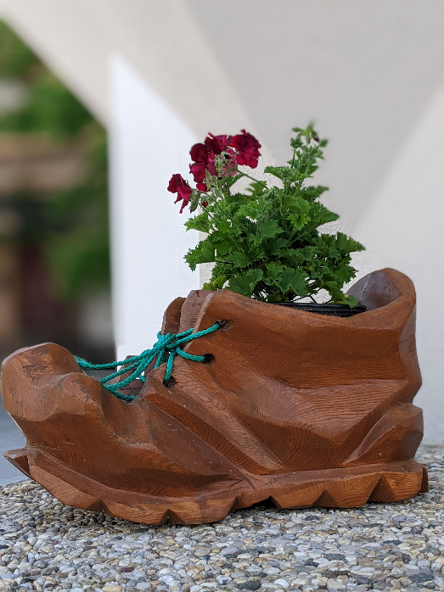

As our building work commences there is NO access to the church during the week, however worship services will be held as normal – entrance will be by through the rear doors. Please note there is very limited parking, so can we encourage you to walk (if you can), share transport or if you have to bring your car, please park in one of the town car parks. Thank you.

**Vision Verse –**

**‘Enlarge the place of your tent, stretch your tent curtains wide, do not hold back; lengthen your cords, strengthen your stakes’ – Isaiah 54:2**

**Verse of the Year –**

**‘Commit to the Lord whatever you do, and He will establish your plans’ – Proverbs 16:3**

…………………………….

Our summer services will be all-age worship led by our Home Groups – as follows:-

27th July – Paul & Emma – In it together

3rd August – Vic & Mary – Saved to sing

10th August – David & Christine – Praying with power

17th August – Steve & Kate – Expect the unexpected

24th August – Jan – Gospel to Go

31st August – Neil – The goal of the gospel

**Rooted Life Magazine**

The next issue (August/September issue) of The Rooted Life magazine is scheduled to be available on August 3rd. Can you contribute something? Please

Make sure your article is either left in the Church Office, on 27th July or emailed to [office@wymondhambaptist.org](mailto:office@wymondhambaptist.org) by 28th July

**PLEASE NOTE –**

Paul is not available from 28th July to 31st August – He will be on holiday from 9th August to 24th August and on sabbatical for the rest of this period. Any concerns or needs should be brought to Gill Price during this period – Please do not disturb Paul or the family during this time.

**Dates for your Diary:-**

**July 27th – Worship at 10.30a.m.**

**July 29th – POWER HOUR at 10.00a.m.**

**At 3 Westwood Gardens, NR18 0DP**

**Aug. 3rd - Worship at 10.30a.m.**

**Aug. 5th – POWER HOUR at 10.00a.m. by zoom**

**ID 81703550775, Password - Prayer**

**Aug. 10th -Worship at 10.30a.m.**

**Aug. 12th -POWER HOUR at 10.00a.m. by zoom**

**ID 81703550775, Password - Prayer**

**Aug. 17th -Worship at 10.30a.m.**

**Aug. 24th –Worship at 10.30a.m.**

**Aug. 31st -Worship at 10.30a.m.**

**Sept. 7th – Worship at 10.30a.m.**

**Sept. 14th 200th Anniversary Celebration at Attleborough**

**Baptist Church – 10.30a.m.**

**Sept. 20th 200th Anniversary Hog Roast at Attleborough**

**Baptist Church – 12.30p.m.**

**Sept. 28th Church Meeting at 12.30p.m. after**

**Morning worship.**

**Although we are unable to enjoy refreshments after our morning worship during the build, please stay and share together as we support one another.**

**PLEASE NOTE WE WILL NOT BE LIVESTREAMING OR RECORDING OUR SERVICE DURING THE BUILDING PROGRAMME.**

**SAMARITAN’S PURSE**

**SHOEBOX APPEAL**

Operation Christmas Child is a project of Samaritan’s Purse. It is a hands-on way for us to bless children in need across the world by filling shoeboxes with toys, personal care items, school supplies, and fun gifts.

Our Shoebox Sunday is planned for Sunday, 26th October. During the summer months think about items to put in your shoebox – what can you collect to put in your shoebox. Pre-prepared cardboard boxes are available from the Church Office.

**Prayer Focus – THE BUILD**

**Please continue to pray through the current pray for all involved in the building project as we move forward into this new phase in the life of Wymondham Baptist Church:-**

1. **Pray for the Architect – John Western and the builders – Greystone and Mason – for those responsible for the day to day work that the project will bring glory to God**
2. **Our neighbours and the local community – Pray for good relationships with our neighbours as the build progresses.**
3. **Those in leading roles – the Architect, the Church Trustees, the Project Manager – Pray for good communication and team work.**
4. **Thank God for the funds that have been promised and the External Fund raising team as funds are drawn down as building work progresses.**
5. **The Church Fellowship – Pray that we will care for one another through this time of disruption and change. Pray that God will reveal to us where He wants us to be in five years from now.**

**CONTACT DETAILS FOR MEMBERS OF THE LEADERSHIP TEAM:-**

Gill Price – 07796274037 – [gillprice@hotmail.com](mailto:gillprice@hotmail.com)

Jason O’Dell – 07990014396 – [jasonodell@btinternet.com](mailto:jasonodell@btinternet.com)

Vera Cooke – 07709766007 – [vcooke6@gmail.com](mailto:vcooke6@gmail.com)

Keith Hilton – 07429502994 – [keithhilton1948@icloud.com](mailto:keithhilton1948@icloud.com)

Mathew Mutokonya – 07878735592 – [blakersyl@gmail.com](mailto:blakersyl@gmail.com)

Jan Hunt – 07812101383 – [janhunt174@btinternet.com](mailto:janhunt174@btinternet.com)

Church Administrator:-

Cathy Finch – 07792711407/01603960940 [- hethersett65@gmail.com](mailto:-%20%20%20%20%20%20%20%20%20%20%20%20%20%20%20%20%20%20%20%20%20%20%20%20%20%20%20%20%20%20%20%20%20%20%20%20%20%20hethersett65@gmail.com)

Website: [www.wymondhambaptist.org](http://www.wymondhambaptist.org)

Facebook: @wymondhambaptistchurch

Email: [office@wymondhambaptist.org](mailto:office@wymondhambaptist.org)

Telephone: 01953606520