THE ROOTED LIFE

Colossians 2:7
‘…….continue to live your lives in him, rooted and built up in him…..’ from the Bible

Date: April/May 2023

A WBC MAGAZINE

Welcome to news from the Baptist family of Wymondham, Roots Community Café and the local community.

In this edition…

Easter is here ……………………………………..

Welcome to the tenth edition of our bi-monthly magazine.

We hope that you found the earlier editions interesting, this issue has more items of interest contributed by a variety of different people - we hope there will be something of interest to everyone. If you would like to write something for our next magazine, please drop it in to Wymondham Baptist Church Office by Sunday, 28th May 2023.

In this edition we hope you enjoy the following…

Contents
- Message from our Pastor page 3
- A Word from Rosedales page 4
- A Butterfly Future page 5
- Dates for April page 6
- Dates for May page 7
- A Good Book to Read page 8
- Spring Worship Walk page 9
- The Dream page 10
- Summer Supper page 11
- Easter Word Search page 12

A message from Paul Smith, our Pastor at WBC…..

So clocks have changed and longer days have returned! As I wrote in the last copy of our magazine it can seem a long while coming. But at last as promised Spring has arrived. A time of new hope and new beginnings. Sunshine tries to breakthrough on a more regular basis and we can begin to feel it’s warmth on our faces. Flowers are peeking through and there are spring lambs everywhere.

David Hockney wrote a book ‘Spring cannot be cancelled’. What fantastic words! It is promised every year that it will come. Also at this time of year Easter is celebrated across the world by Christians. It is a time of excitement and great joy, as well as reflection and remembering that Jesus died on a cross and was buried.

Also coming up in the next few months will be the King’s coronation. A time when as a nation we come together to hail in the new monarch. It is a big change for us all as most of us will only ever have known the reign of Queen Elizabeth the second. Charles will take the mantle and lead us forward into the new phase of the life of the nation.
As part of the ceremony he will make promises to us as a nation and we will pledge promises to him. These are important statements of intent. They have weight and meaning and history. In a world where truth and dedication are rare commodities, it is important that these pledges are taken seriously. Just lately our news has been filled by the stories of public figures breaking promises and pledges. We are seeing former prime ministers questioned about their standards and a failure to keep pledges. Across the waters in the USA we are seeing ex presidents in the same boat. It seems it’s hard to know who you can trust in this day and age. It seems to me as though all their promises are…..well…..empty.
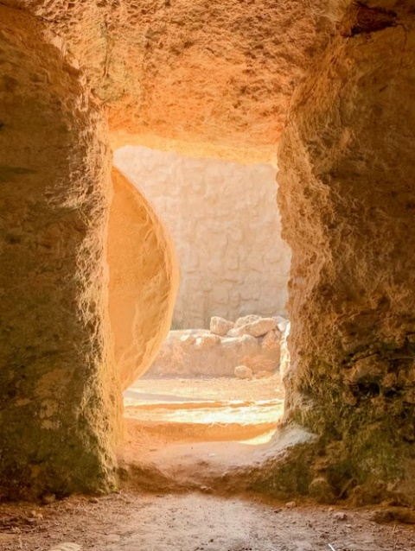
But it is an empty promise that brings me hope. Because although I said at the beginning that you cannot stop Spring, as it was promised and that Easter is celebrated as it was promised there is also the empty promise of the tomb. Because of the empty tomb we know that Jesus not only died was buried but he rose again to life in victory. God’s plan of redemption for all those who believe in Jesus, like Spring, could not be stopped. Jesus the lamb of God delivers us from the ‘winter’ of death into the ‘spring’ of new life. An empty promise that can be fully trusted.

We pray that you are blessed over this Easter holiday and that as you see lots of new life perhaps remember that Jesus offers all to join him in eternal life.

Blessings

Paul

A WORD FROM ROSEDALES

By the time this magazine is published, we may know the answer to the question……..Will Prince Harry and his wife attend King Charles’s coronation?
I’m sure many of you will not care about the answer to this question!
I admit I do have a bit of a fascination with the Royal family and yes, I have read Prince Harry’s book ‘Spare’! I am not a particular fan of his, but I wanted to hear his side of the story, directly from ‘the horse’s mouth’, rather than through a second hand account given by journalists or columnists.
There are many cringe -worthy moments recounted in his book and in my view, he gives far too much detailed information about things which should remain private!
As I read the book, I saw that his account of things was what he believed to be the truth. No doubt his father, brother and other family members have a completely different version of events which they also believe to be true!
Putting all the disagreements and accusations aside, it seems to me that at its core, Prince Harry’s book is about grief and loss. As a twelve year- old boy, he was devastated by the sudden and tragic death of the person closest to him. He talks a lot about his beloved Mother’s death. His grief journey details many of the common themes of grief shared by others who are bereaved:
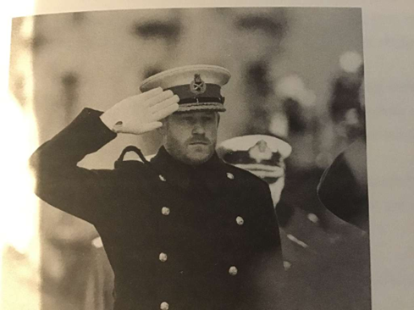
For a long time he was in shock, disbelief and denial and simply could not accept she had died, believing instead that she had gone into hiding. Those who are bereaved talk about a sense of unreality, expecting that their loved one will walk through the door at any moment.
He needed to visit the tunnel where she died several times. This is a common response when unresolved questions remain due to not being present at the moment when our loved one died. This response can also help the bereaved person feel close to their loved one by maintaining a continuing bond and connection.
He describes rowing across to the island at Althorp House where his mother is laid to rest, taking his then, new girlfriend Meghan, ‘home to meet mum’. As well as everyday life, many bereaved people find special occasions difficult to bear without their loved one. It is often at these times that their absence feels all the more real and painful. Many people find ways to include their loved one in special occasions, such as eating their favourite meal on anniversaries or birthdays, raising a glass to them at important celebrations or visiting their favourite place.
Whoever we are, rich or poor, famous or not, grief affects us all. We do not ‘get over’ the loss of our loved one, but find ways to carry on whilst continuing to remember, love and miss them. We take them with us as we move forwards with life.
The next Rosedale bereavement support group begins on the 9th of May at the church. The course is free and open to anyone. Please call 07901 888 122 to reserve your place.
Sarah (Rosedales)

A Butterfly Future?
Imagining the future can be deeply unsettling. Rising temperatures, drought, flooding, storms, unpredictable weather events are already showing themselves to be the result of climate change caused by fossil fuel burning. The latest Intergovernmental Panel on Climate Change (IPCC) report shows that our target of staying below a 1.5 degree C increase by 2050 is unlikely to be met. Predictable impacts are loss of human lives, human livelihoods, food shortages, extinction of plant and animal species and breakdown of society. But what if we could do something about it? It does not have to be this way…
Now imagine a world where community spirit is strong, people come together, watch out for each other, help each other. We have seen this happen during World War ll; community solidarity led to suicide rates plummeting.
Rupert Read, professor of philosophy at UEA, describes 3 possible scenarios: the Dodo – extinction, the Phoenix – rising from the ashes or the Butterfly – reborn without having to die first. Let’s aim for a Butterfly future where we work with and for each other, together with, not separate from nature.
If you want to be part of this, share your imagination of a better future with others, find support, share ideas and take action, come along to this FREE talk and workshop:
A Butterfly Future? Monday 24 April 6pm to 8pm at the Abbey Hall, Church St, Wymondham NR18 0PL. Doors open 5.30pm. Led by Rupert Read, UEA, author of ‘Why climate breakdown matters’ and ‘Parents for a future’. Supported by Greening Wymondham www.greeningwymondham.com
Books by Rupert Read will be available for purchase. Cash only please.

Nicola Maunders, Greening Wymondham

DATES FOR APRIL:-

April 2nd Worship including communion at 10.30a.m.
April 4th POWER HOUR – 10.00a.m. in the Prayer Room
April 5th Rosedales monthly bereavement group – 10.00a.m.
April 6th Maundy Thursday Reflections – 6-8.00p.m.
April 7th Walk of Witness – Meet 10.30a.m. at RC Church
April 9th All Age Easter morning Service – 10.30a.m.
April 11th POWER HOUR – 10.00a.m. in the Prayer Room
April 14th Roots Community Café at WBC – 10.00a.m. – 1.00p.m.
April 15th Film afternoon – Is Heaven for Real – 2.30p.m.
April 16th Worship at 10.30a.m.
April 17th Roots Community Café at WBC – 10.00a.m. – 1.00p.m.
April 17th Leadership Team Meeting – 7.30p.m.
April 18th POWER HOUR – 10.00a.m. in the Prayer Room
April 18th Thrive@Roots – 2.30p.m.
April 21st Roots Community Café at WBC – 10.00a.m. – 1.00p.m.
April 21st Friday Night Youth – 6.30p.m.
April 23rd Worship at 10.30a.m.
April 24th Roots Community Café at WBC – 10.00a.m. – 1.00p.m.
April 24th Building Project Meeting – 7.30p.m.
April 25th POWER HOUR – 10.00a.m. in the Prayer Room
April 25th Thrive@Roots – 2.30p.m.
April 26th POWER HOUR – 7.30p.m. – 8.30p.m.
April 27th Alpha Course – 6.30p.m.
April 28th Roots Community Café at WBC – 10.00a.m. – 1.00p.m.
April 30th Worship at 10.30a.m.
April 30th Worship Walk at Ashwellthorpe Woods

Alpha Course starts at WBC on Thursday, April 27th – Have you got questions you would like to ask about the Christian faith – come along and see what you can find out.
April 27th – 6.30p.m.

DATES FOR MAY –

May 2nd POWER HOUR – 10.00a.m. in the Prayer Room
May 2nd Thrive@Roots – 2.30p.m.
May 3rd Rosedales Monthly Bereavement Group – 10.00a.m.
May 4th Alpha Course – 6.30p.m.
May 5th Roots Community Café at WBC – 10.00a.m. – 1.00p.m.
May 5th Friday Night Youth – 6.30p.m.
May 7th POWER HOUR – 9.00a.m. in Church Lounge
May 7th Worship including Communion at 10.30a.m.
May 8th Roots Community Café at WBC – 10.00a.m. – 1.00p.m.
May 8th Leadership Team Meeting – 7.30p.m.
May 9th Rosedales Bereavement Course – 10.00a.m.
May 9th POWER HOUR – 10.00a.m. in the Prayer Room
May 9th Thrive@Roots – 2.30p.m.
May 11th Alpha Course – 6.30p.m.
May 12th Roots Community Café at WBC – 10.00a.m – 1.00p.m.
May 14th Worship at 10.30a.m.
May 15th Roots Community Café at WBC – 10.00a.m. – 1.00p.m.
May 16th Rosedales Bereavement Course – 10.00a.m.
May 16th POWER HOUR – 10.00a.m. in the Prayer Room
May 16th Thrive@Roots – 2.30p.m.
May 18th Alpha Course – 6.30p.m.
May 19th Roots Community Café at WBC – 10.00a.m. – 1.00p.m.
May 19th Friday Night Youth – 6.30p.m.
May 21st Worship at 10.30a.m.
May 22nd Roots Community Café – 10.00a.m. – 1.00p.m.
May 23rd Rosedales Bereavement Course – 10.00a.m.
May 23rd POWER HOUR – 10.00a.m. in the Prayer Room
May 23rd Thrive@Roots – 2.30p.m.
May 25th Alpha Course – 6.30p.m.
May 26th Roots Community Café at WBC – 10.00a.m. – 1.00p.m.
May 28th All Age Worship at 10.30a.m.
May 30th Rosedales Bereavement Course – 10.00a.m.
May 30th POWER HOUR – 10.00a.m. in the Prayer Room

TEST YOUR WORD POWER!!

How many words can you make out of Coronation?

A GOOD BOOK TO READ –
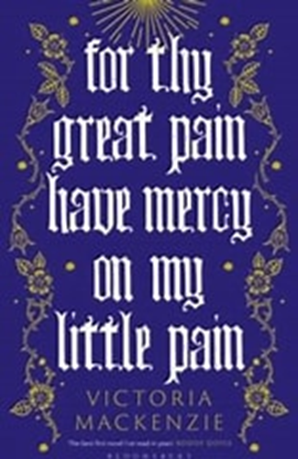
Two extraordinary women living during the C15, one in Kings Lynn the daughter of a merchant, and the other a daughter of a wealthy family in Norwich. Both their lives included family loves and losses, the latter due to the plague which was rife at this time. The book is almost like a conversation between the two women, both with an overwhelming desire to tell others of the sacrificial life of Christ but following different routes to do so.

Margery Kempe was led to preach in the streets and marketplaces of her town, often very emotional and resulting in hostility and possible condemnation as a heretic. Julian by comparison, wished to spend her life and time alone with God, and to deepen her relationship with, and understanding of, Him. She had had several ‘shewings’ (visions ) when very ill and near death at a young age, and felt compelled to write down these experiences. The latter part of her life was spent as an anchorite (hermit), entering voluntarily into a small, stone cell attached to a church and living a life of isolation, writing and spending time in prayer and contemplation. Julian spent twenty three years in her cell up to the time of her death during which time she wrote down her visions of the love and Passion of Christ which is published as “The Revelations of Divine Love “.

The book finishes with their meeting when Margery visited Julian in her cell, seeking spiritual help with her anxieties and fears about the visions of Jesus that troubled her. I think they must have had much to share.

The book is not a difficult read, but I found it rewarding to take it more slowly and read a second time. The restrictions on women, the pain they suffered primarily as mere chattels and of little consequence are subtly inferred but the beliefs and love of God and the need to tell others in these two women has survived down the centuries.

Mary Kirk

(If you would like to read this wonderful novel, Kett’s Books in Wharton Court, Wymondham, has copies in stock.)

Wymondham Baptist Church is now a Charitable Incorporated Organisation registered with the Charities Commission – Charity No. 1199302

New Bank Account details:- Lloyds Bank, Sort Code – 30-90-89, A/c No. 47748863

Save the date!
Spring Worship Walk
Sunday 30th April
Come and join us for a spring walk in Ashwellthorpe woods. We will be leaving WBC at 3pm and returning about 5pm. It will be a time to look, hear and reflect on God’s creation at this lovely time of year, either with friends and family or quietly by yourself.
More details will follow but please put the date in your diaries. It should be a lovely time of outdoor fellowship.

WYMONDHAM EASTER SUNDAY DUCK RACE ON THE TIFFEY–
Start at 11.30a.m. on 10th April at Becketswell.
Join in the fun.
The Dream

One night, in a dream, I came to a place,
Golgotha was its name.
In front of me, three crosses of wood,
And on each hung a man.
As I looked into the eye of one,
I saw, mingled with pain
Forgiveness and love for those
Who tried to bring him shame.

I turned my head, I could not bear
To watch his agony.
I told myself I had no share
Of responsibility.
And then a hammer struck the nails
That held him to the tree,
And drops of blood fell down upon
My head, my hands, my feet.

And suddenly I realised
A truth too great to bear -
That every worldly, selfish act
I did had put him there.
And every time I allowed myself
A deed or thought impure,
Or put myself before all else,
The hammer struck once more.

As, through my tears, I gazed upon
His marred, yet loving face
He whispered to me ‘Peace, my child,
I’m here to take your place’.
The drops of blood upon my head
Had washed away my sin.
And through his death, and through his love,
I have new life within.

Neil Starling

You are invited to a
Summer Supper with Speaker
On Friday 2nd June from 7.30pm
at Wymondham Baptist Church
A simple ploughman’s supper will be followed by a local speaker, Hannah Gray who will be talking about the global work of the A Rocha charity and it’s UK project, Eco Church.
Tickets are £7.00 available from Nicki, Jan, Cathy and Robbie.
Please purchase your ticket by Monday 22nd May and let Cathy know of any dietary requirements.
Come along to enjoy a tasty meal and find out more about the exciting work of this worldwide charity.

