WBC summer notice sheet
Welcome to our news for the church August-September
(Please note this publication covers the period 24th July to 3rd September – the next weekly notice sheet will be issued on 4th September)

Introduction
Welcome to our summer newsletter. We hope that you find this informative and it gives you both encouragement and dates for your diary.

This summer our services will be all-age worship led by those in our home groups and our focus will be on…

Creation - Why should we care?
Date Leading Theme

Sunday 24th July Paul Overview of series

Sunday 31st July Jan / Nicki Light

Sunday 7th August Vic / Ray Water

Sunday 14th August Christine Vegetation

Sunday 21st August Neil Creatures

Sunday 28th August Ramona Wrap up and praise

Verse of the Year – ‘If we live, we live for the Lord; and if we die, we die for the Lord. So, whether we live or die, we belong to the Lord’ Romans 14:8

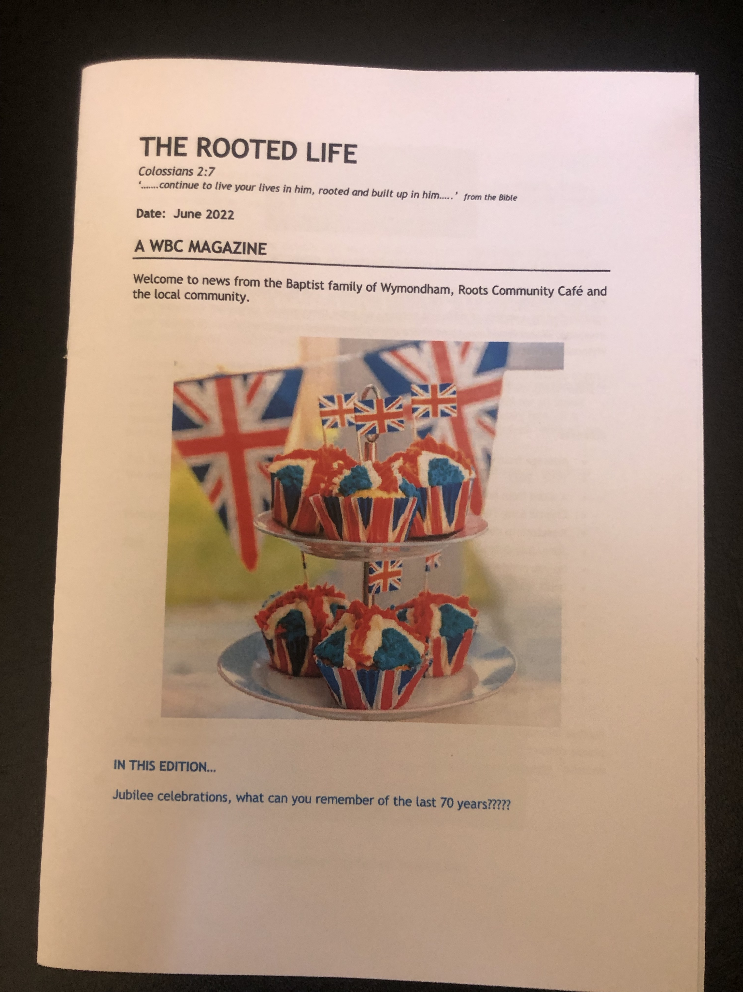
Rooted Life magazine out early August

The next copy of our bi-monthly magazine for August - September will be available soon (August 7th). Make sure you grab your copy to see interesting articles and latest news. It is an ideal way to know what’s on and also know more about the life of WBC and beyond!
As always we are always looking for new content so if you feel this is something you could contribute to, please speak to Cathy in the office or email office@wymondhambaptist.org

Big church clean

August sees us take part in our Big Church Clean. We plan to clear out all unneeded and unused items from the church and give our whole premises a big clean. This will take place from August 1st to the 13th inclusive. There are dedicated leaders for each area and a proposed total clean down on the 13th. During this time there will be a skip provided and help needed in all sorts of areas, including recycling and giving away items that may be of use to others. We ask that if you have personal items at the church that are not used please collect them. If you can help in any way shape or form we would be grateful of your assistance.
Please speak to either the leadership team, email office@wymondhambaptist.org or ask Cathy. A schedule of cleaning tasks to be done on 13th August will be displayed in a week or two, so please sign up to help.

An invitation from

Carleton Rode Baptist Church and Attleborough Baptist Church
If you would like to meet Alan and Megan Barker, our BMS missionaries, you are invited to join Carleton Rode Baptist Church on Saturday, 6th August at 7p.m. for desert and an informal evening or Attleborough Baptist Church on Sunday 7th August at 2.30p.m. for a time of fellowship followed by refreshments. To help with catering at Attleborough Baptist please let either Malcolm Maddieson (malcolmmaddieson@gmail.com)or Elizabeth Briggs (EBriggs17@hotmail.com) know if you are able to join them.
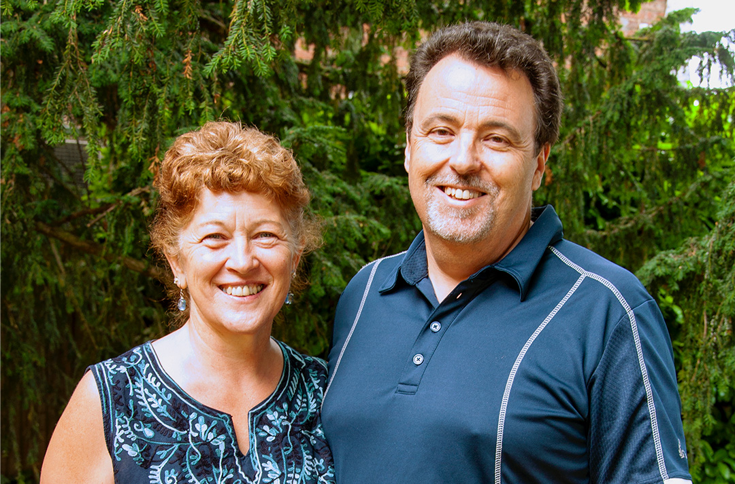

WBC Summer BBQ

Sunday 4th September

Please join us after our BACK TO CHURCH Sunday service on the 4th of September for a BBQ.
All food will be provided however please bring along your own soft drinks.
This is a great time of fellowship, of getting to know each other and catching up together after many of us will have been away on our summer holidays.
Keep your eyes out for more details via the website or email news.

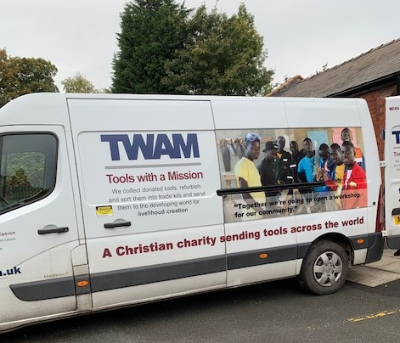
WBC tools with a mission collection
The collection day will be on Saturday the 17th September between 10.00a.m. – 4.00p.m. If you can help on the day please speak to Christine, Nicky or Cathy.
Then on Sunday the 18th we will spend our morning worship time with a focus on the work of TWAM in an all-age service.
As in previous years we will be collecting old tools for TWAM. We are looking to collect any unused old tools which will be sent off to be refurbished before being shipped out across the world.
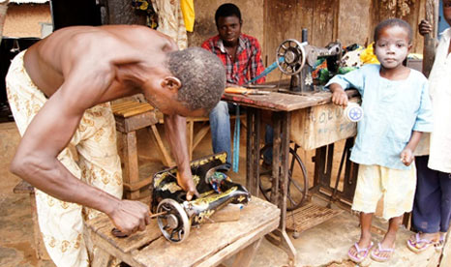

Church meeting date change!
Please note the new date for our September church meeting, as agreed at our meeting on Sunday, 17th July is now Thursday evening 15th September starting at 7:30pm.
We, as leadership want to remind people of the importance of gathering together as a family to discern the way forward as a church family, together.
For more information please read the minutes from our July meeting, which are available on the church notice board in the corridor.

OUR VISION – To be ‘An authentic church with a place for everyone’

Upcoming EBA events

Please speak to Paul about the latest upcoming events from the Eastern Baptist Association.

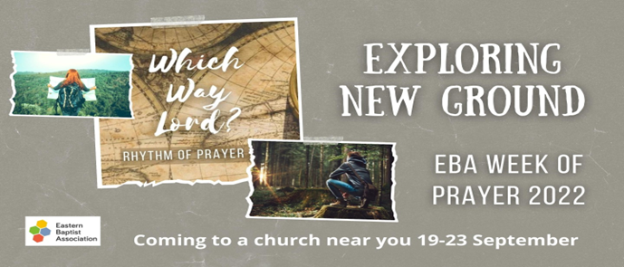

Put the dates in your diary – more information to follow

Other events……

Flourish women’s conference takes place on Saturday 24th September in Thetford. Tickets are still available and if you would like to go please ask Emma for more info or see the leaflets in church.

Also starting on the 24th September is Wymondham’s very own Green week, a week long focus on how we can help reduce our environmental impact. We at WBC have committed ourselves through taking part in Eco church to look at the way we can be more sustainable as a church. Perhaps this is something that you would like more information on? If so please speak to Nicki as I am sure she would love to tell you more about it.

Roots closures during the summer……

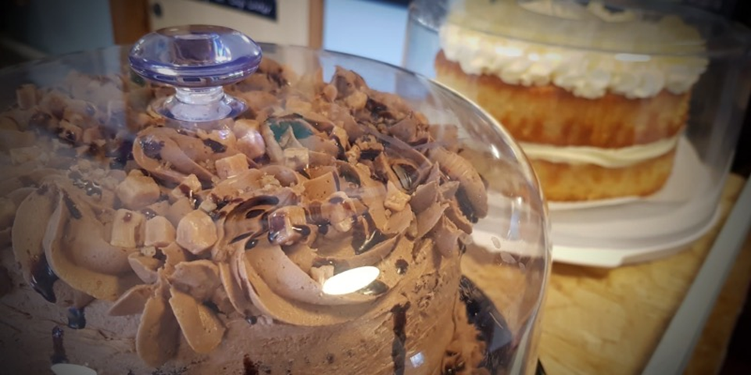

Our very successful outreach project Roots Community Café will be closed for two weeks during August. The last session will be on Monday the 15th August and we will re-open on Friday the 2nd September.

We just want to say a massive thank you to all our wonderful helpers and supporters without whom we would not be able to reach out in the way we do.

It is with grateful hearts that we see God at work through all the regular effort and prayers from all involved.

Please continue to remember in your prayers, thoughts and actions:- Mary and Vic, Jenni and family, Jane, Paul, Emma and the family, Brian and Jeanette, Penelope, Henry, Penny’s daughter Fiona and many other members of the fellowship facing difficulties at this time. Also continue to pray for peace in Ukraine.

Leadership news
As agreed at our latest church meeting the leadership is to be joined by two new members. We welcome Jason O’Dell and Neil Starling to the group. We look forward to seeing their gifting used to help us move forward in the future. As also stated at the meeting, Ramona Chenery is taking a short break at this time for personal reasons. Please pray for her.

On another note Paul and the family will be taking their summer holidays from the 16th August until the 30th August. If you need anything during this time please contact one of the Elders (Gill Price or Vic Wright) or one of the other members of the leadership team.

We ask that you as a church pray regularly for those in leadership roles as they seek God’s will and help with many of the practical tasks that need to be carried out.

August Prayer Focus: Wymondham foodbanks

Given the current economic climate and the news of how many more people are struggling to make ends meet, let’s join together this month to pray for our foodbanks…plural!
Roots café have a ‘Pay it Forward’ board and we have noticed a marked increase in visitors making use of this.
At WBC, we also work with the Norwich foodbank which is part of the Trussell Trust. There is now a table in the lounge during Roots on Fridays that is reserved for the foodbank and clients are directed there if they have need. The volunteers are from across the town and give out pre-packed boxes and bags of food and essentials. There has been a noticeable increase in people needing access to the foodbank and according to the latest Norwich newsletter, 48% are from people who are in work but still have trouble managing.
Since 2018, the Catholic Church in Wymondham has also organised a foodbank and Community Fridge which serves the local parish (from Attleborough to Hingham, Bunwell and Little Melton). It too is gospel inspired and is run by volunteers of different faiths and of none. Packs are made up individually for each recipient according to their need.
If you can, please pray for……
- Those in need, especially those who are afraid to ask for help.
- Local businesses, organisations, and individuals, who through their gifts, enable these projects to serve those in need.
- Our volunteers who seek to ease hardship and bring hope.
- Ourselves, that we might be prompted to show compassion and, modelling ourselves on Christ, to share His love and kindness to all in need.
To find out more about the organisations mentioned above, please go to:
www.norwichfoodbank.co.uk (www.trusselltrust.org)
www.community@wymondhamrcchurch.org.uk
www.wymondhambaptist.org.uk
John Wesley’s Rule:
Do all the good you can,
By all the means you can,
In all the ways you can,
In all the places you can,
At all the times you can,
To all the people you can,
As long as ever you can .

Home
from
Home
Would you like to be part of something new that we are hoping to set up between the end of September and March of next year, on Wednesday and Thursday afternoon, between 2.00p.m. and 5.00p.m. All of us will be facing the effects of increased energy costs and for some it will mean the choice of heating or not heating their homes or living in very low temperatures. Home from Home is designed to provide a warm space in the church for everybody where they can simply come, meet with other people, play board games, do puzzles, read the newspaper, chat and enjoy tea/coffee and biscuits. We are looking for a group of people that will be happy to be part of the hosting team for this project. If you are interested in learning more, please speak to Ray or Cathy Finch.

Dates for your diary:-

25th July Roots Community Café – 10.00a.m. – 1.00p.m.
26th July Building Project Meeting – 7.30p.m.
29th July Roots Community Café – 10.00a.m. – 1.00p.m.
31st August All-age worship – 10.30a.m.
1st – 13th August – Big Church clear out and clean
1st August Roots Community Café – 10.00a.m. – 1.00p.m.
1st August Finance Team meeting
3rd August Rosedale monthly meeting – a.m.
5th August Roots Community Café – 10.00a.m. – 1.00p.m.
6th August Meet Alan and Megan Barker at Carleton Rode Church - 7pm
7th August All-age worship – 10.30a.m.
7th August Meet Alan and Megan Barker at Attleborough Baptist Church - 2.30p.m.
8th August Roots Community Café – 10.00a.m. – 1.00p.m.
12th August Roots Community Café – 10.00a.m. – 1.00p.m.
13th August Big Church Clean
14th August All-age worship – 10.30a.m.
15th August Roots Community Café – 10.00a.m. – 1.00p.m.
21st August All-age worship – 10.30a.m.
28th August All-age worship – 10.30a.m.
2nd Sept Roots Community Café – 10.00a.m. – 1.00p.m.
4th Sept Back to Church Sunday
4th Sept Church BBQ after service
5th Sept Roots Community Café – 10.00a.m. – 1.00p.m.
7th Sept Rosedale Monthly meeting – a.m.
9th Sept Roots Community Café – 10.00a.m. – 1.00p.m.
9th Sept Friday Night Youth

Contact details for members of the Leadership Team:-

Vic Wright 01953850617 marvicwright@talktalk.net - Elder
Gill Price 07796274037 gillprice@hotmail.com - Elder
Victor From 07565919143 victor.fromm333@btinternet.com –
- Treasurer
Ray Finch 01603960940 ray.finch@live.co.uk – Secretary
Nicki Waterworth 07854452093 nickiwaterworth@gmail.com
Neil Starling 07881202513 starlingneil@gmail.com
Jason O’Dell 07990014396 jasonodell@btinternet.com

Website: www.wymondhambaptist.org
Facebook: @wymondhambaptistchurch
Email: office@wymondhambaptist.org
Telephone: 01953606520

