Wymondham Baptist Church
2023 Annual Reports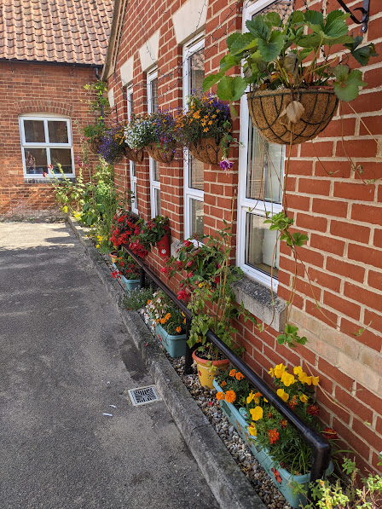

Preface from our Pastor

As you read this report, I pray that you are as encouraged as I am. There are lots of positive things happening in the life of WBC, not least of which is the numerical growth of the church. I thank all those involved in helping us to continue to reach out to each other and to those who are in contact with us, though various different ways, with the love of God. I thank you for all your hard work and sacrificial giving, for your prayers and support over the past 12 months.
I thank you for the love you demonstrate as a fellowship.
However, I wish to keep the following at the forefront of our minds - ‘Unless the LORD builds the house, the work of the builders is wasted. Unless the LORD protects a city, guarding it with sentries will do no good’ Psalm 127: 1 (NLT)

It is important that we do not puff our chests out as some kind of proud peacock but instead give thanks in humble adoration as to what God has been doing amongst us. It is He whom has been at work and we have the great joy and privilege of joining Him in that. Let us stay focused and forever searching him for the ways forward.
I look forward to the future.

As the song by Maverick city music goes ‘I thank God’

Blessings
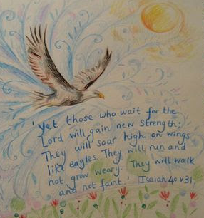
Paul

Wymondham Baptist Church
Annual Reports 2023
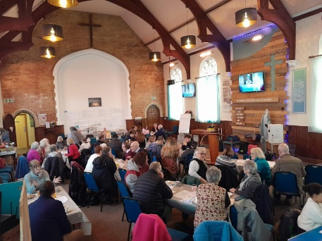

Verse of the Year 2023:
‘Have I not commanded you? Be strong and courageous. Do not be afraid; do not be discouraged, for the Lord your God will be with you wherever you go.’ Joshua 1 verse 9

Vision Verse –
“Enlarge the place of your tent, stretch your tent curtains wise, do not hold back, lengthen your cords, strengthen your stakes.’ – Isaiah 54:2

Reports
Pastor Page 5
Prayer Life at WBC Page 9
Roots Community Café @ WBC Page 10
Thrive@Roots Page 11
Sunday Youth Church Page 12
T412 Page 13
Friday Night Youth Page 15
Secretary Page 16
Church Administrator Page 18
Treasurer Page 19
Music in Worship Page 22
Buildings, Garden and Maintenance Page 22
Outreach and Mission Page 24
The Falconer Trust Page 25
Homegroups at WBC Page 26
Eco Church Page 27
Café Church Page 32
Care in the Community/Home Communion Page 33
Home from Home Page 34
Building Project Team - Propose extension Page 35
WC Building Project External Fund Raising Group Page 36
Windmill House Page 37
Gallery of 2023 Page 38

Pastor
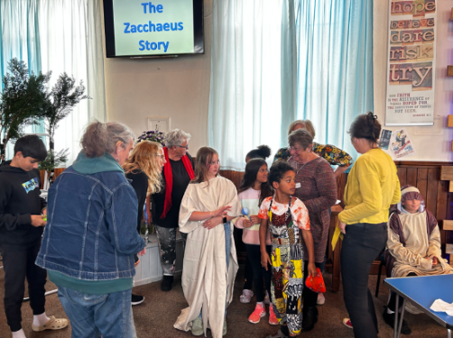
I cannot believe I am sitting here again at my computer trying to capture another year that has passed. Where does time go. As always I am grateful to Cathy for helping me collate what happens in church life as we meet regularly and try to record month by month the events as and when they transpire. It always amazes me as I reflect on the past 12 months just how much WBC does! I will, as per usual, not mention everything nor go into in depth detail as many things will be duplicated in these reports by others, but, suffice to say I pray you are as encouraged as I am when you read them.

I can categorically say that in all my time here as pastor of WBC we have never known a year of growth numerically like 2023. We started out the year in January with 43 people in membership and by December had 55 people. Praise be to God for the increase in the harvest. This figure though only tells part of the story as that is just the number of people who have applied to be members. There has also been a large increase in the number of people who regularly attend our times of worship on Sunday mornings and also others who join in with the life of the fellowship.

January saw my ordination service take place where I ‘officially’ became Rev Paul Smith. It was a great celebration to be part of. For those of you who have been here from the start of this journey way back in 2012 it seemed a long while coming. However all good things come to those who wait (not a biblical verse) but it holds some truth. God’s timing is always perfect. My thanks go to all who helped organise the day, to Chris Duffett who brought the message and the challenge, to those from other churches in the town who joined us and to the local councillors who came along. But special mention must go to Ray Finch who took the lead and organised everything. He will always hold a special place in my heart for his kindness and compassion and the way he longed to see this celebration as a significant marker for the church. I think he was right as it was from this point that we, WBC, started to see the growth. We hosted cafe church again and we continue to see this ministry grow. We also held a whole church prayer gathering.

Sadly, as February came upon us Ray was rushed into hospital and subsequently died. I cannot express how devastating I found this on a personal level. In fact I have to admit as I sit here today I still have not come to terms with it all. As a church we greatly miss Ray’s gifting and his wisdom. I cannot write in this report all I would like to say about this, just to say our love and prayers continue to Cathy. I can only cry out to God and ask him to help us to come to terms with it all.

As we entered March we held our very first seed swap event as part of our ECO church mission. This was very well attended and a great building block to reaching out to the community. I had the privilege of sharing our vision as a church with the Rotary group, explaining our plans for the futures. The end of that month saw us host our final Home from Home as the better weather approached. We also held our AGM.
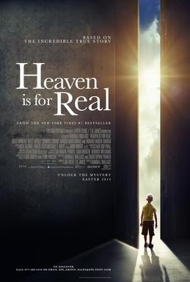
April saw the beginning of the powerhouse prayer focus. We also gathered for the film showing of ‘Heaven is for real’ before embarking on a sermon series looking at what we believe as Christians about life after death. Beth Powney retired from her role as regional minister and I was delighted to speak at her farewell gathering. I was greatly encouraged by a conversation I had with Lynn Green who is the general secretary of the BU saying she recognised me and indeed the church here at WBC from the Home Mission film we had been part of. We started a new Alpha course and also enjoyed a worship walk together in Ashwellthorpe woods.

In May we, like the nation, watched the King’s coronation take place as a new era dawned upon the country. We gave out books as commemoration of the occasion. We were also paid a visit by the Home Mission grants team to see if we were eligible for continued funding here at WBC. It is always good to talk to others about how we believe God is at work here, and nothing speaks to me more about that than baptism. We had two candidates for our service and it was great to celebrate with Finlay and Carol as they answered the call of Jesus to be baptised.

Sadly, we suffered a leak in the kitchen which resulted in some unit damage.

Summer came along and as we entered June the building steering group met with Graham from the County Council as he gave us lots of advice on going forward with funding applications. We then held a day of prayer and fasting to seek God’s continued guidance for the vision.
We looked at the options with regards to the kitchen and started consultations with the insurance company.

By July we had narrowed down what these were and presented them to the church, who desired that we future proof our facilities in line with the vision and so therefore we took a cash settlement from the Insurance Company and work commenced on replacing the entire kitchen. This meant that Roots closed for the summer holidays as works were carried out.

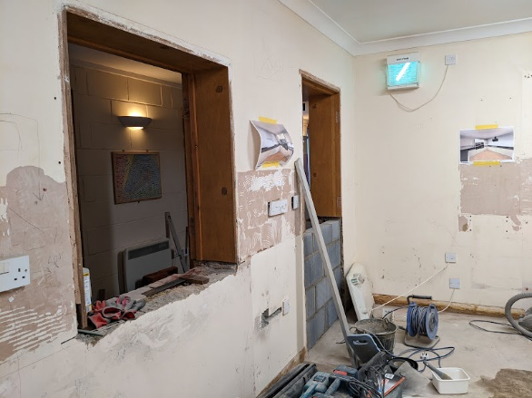
I was invited to join the EBA council and with the church’s approval took on this new role.

In August myself, Emma, Penny and John carried on with the installation of the new kitchen. It was hard work but the results were amazing. We were amazed at the giving towards the works and not just by those who are part of WBC. We had a donation of £3,000 from one couple, who do not go to church, for the work we do.

September was a busy month as we started the autumn term with a big church clean. We had a fellowship BBQ after morning worship which was a great time of fellowship and catching up with each other after a busy summer.

We joined in with the town wide Vintage Day event. This saw many people come along for a day of fun. Though it is always a challenge as we do not have morning worship on that Sunday. I do believe it is a good witness to our community as we share that we are as much a part of the town and not just people out with an agenda.
We also hosted a TWAM collection and as per usual were inundated with lots of tools, but also we were gifted with £80 towards the cafe for the work it does.

In October we hosted a litter pick with Greening Wymondham and held our annual Shoebox Sunday. It was amazing how many boxes we had to send away as part of Operation Christmas Child.
Sadly, we lost Hilary as she died after a very short illness. She is sorely missed and it was such a privilege to have seen her grow in her faith since she came here.
At the end of the month we hosted an ECO focused service looking at how God wants us to think about creation care and we enjoyed a bring and share lunch together.

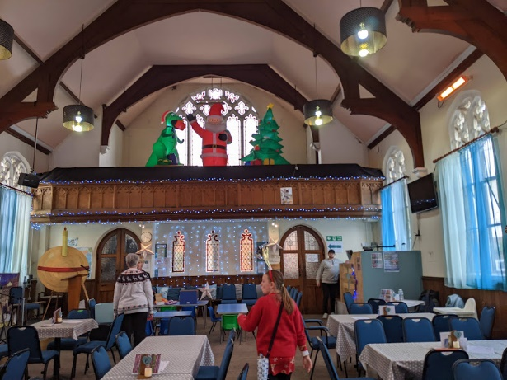
November saw us again take part in Wynterfest as we shared in a Christmas fair sharing the message of what the focus is all about. This continued throughout December. We hosted the Hemsbysingers at a carol concert in support of WBC raising funds for the building project. We also led a service of remembrance in conjunction with Rosedale funeral homes. We held our own Carol service and a youth led service.

As you look back over the past 12 months it is amazing. I often say that as a church we ‘punch above our weight’ with all the ministries we are involved in. It amazes me how much ‘work’ we do. but that is not my focus. It is incredible what we do at WBC but I am not sure that is what amazes me. What does, if I am honest, is just how much we are blessed by God. The verse for the year for 2023 was “be strong and courageous for your Lord your God is with you wherever you go”
Joshua 1:9. This verse was so important to me on a personal level as we faced ups and downs as a church. But as I look back I can see the hands of Christ in so many ways it gives me courage for the future. A future that I believe is looking brighter and exciting. Long may we focus on Jesus, the author and perfecter of our faith, as we enter the new year.

Blessings

Paul

Prayer Life at WBC
This year we started some new prayer initiatives with these aims in mind:
- Encourage and build us up in our personal prayer lives
- Establish a framework of regular church prayer meetings
- Inspire the whole church to experience the power of praying together

- Tuesday Power Hour, 10-11am – this weekly prayer time started in March and now has 4-8 regular pray-ers who say praying together has strengthened and deepened their own prayer lives.
- Day of prayer and fasting for WBC vision, Thursday 29th June – over 20 people participated throughout the day. At the evening prayer time, we prayed around the WBC premises and Paul led us in dedicating afresh the gates of WBC, as per Nehemiah chapter 12.
- Prayer session with young people, Sunday 5th November – it was a privilege to work with Ruth Rallan and young people aged 4 – 14 years, focusing on the Lord’s prayer and then putting prayer into practice. It was great to see all the young people actively participate.
- New Year’s Eve prayer gathering Sunday 31st December – we looked back with gratitude over 2023, sharing testimonies to God’s faithfulness, and praying into 2024 with faith and expectation.
- Monthly prayer meeting in 2024 (7.30-8.30pm first Thursday) – we believe that corporate prayer is the engine room of the church and the Leadership Team has established this monthly prayer meeting in 2024.
We wrote last year of the huge need for prayer for crises facing individuals, our town, our country and our world – the needs are even more complex and challenging as we go into 2024. As God’s people, we believe our prayers bring about change as we intercede for lives to be turned around, saved, delivered, healed. WBC’s vision is to be a church with ‘a passion for prayer’ and like Jesus’ disciples, we come to Him and ask, “Lord, teach us to pray”.

Vera Cooke and Gill Price
Roots Community Café
Roots continues to grow, we are still welcoming new visitors to some sessions but equally have our regulars who have journeyed with us from the beginning.

Changing Monday to Wednesday has worked well and we have seen the day change helping with food waste and easier set up. We have been slower on a Wednesday than a Friday but that is normal and we are not concerned. It allows for more time getting to know our visitors and building stronger relationships.

As always we struggle with volunteers, last year I reported that we hadn’t managed to find someone who can fill the kitchen role completely, but I’m happy to say Jane has really stepped up into this role and can on quieter days cope on her own if needed. Margaret has joined the team and brings a smile to all our faces with her witty sense of humour.

We have seen Bev Woodhouse attend a few services, mostly under the disguise of helping out in the kitchen on cafe church days but slow and steadily feeling more able to turn up and feel welcomed in to other elements of church life.
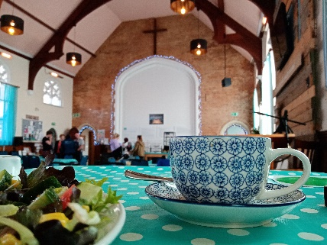
Again there has been an increase in donations to the pay it forward board including a couple of grants we were awarded thanks to Cathy. Sadly there continues to be a high number of people using it due the continuing cost of living crisis.
Shopping bills for Roots have again increased and we will therefore be reviewing our prices at Easter.

The new kitchen has made a massive difference to the day to day running of Roots, we have more space and the eye level ovens really help. The whole layout makes the shift easier to manage.

Roots was pleased to be part of the Vintage day and Wynterfest celebrations in the town, we have had lots of positive feedback about how well we engage in the wider community and make the effort to build relationships with those outside the church. We were told we are always willing to look out and not simply focus on ourselves.

We catered for Hilary Marsh’s funeral, as well as another for a young lad, again showing our love for others using skills we have in the .

I want to thank all those who have helped at Roots, either regularly or as and when, we have defiantly touched our community with Gods love this past year.

Emma Smith

Thrive@Roots

Thrive is our youth cafe that operates on Tuesday afternoons during term times from 2:15-4:30.
It is a ministry that started in order to provide a safe space for the youth school Year 7 and onwards, as the high school day finishes early on Tuesdays. It is run by a small team consisting of Emma, Ruth, Alison and Vic, Paul attends when he can and often works in the main hall.

Thrive continues to go from strength to strength. It has seen a growth in numbers since September with regular attendance now averaging around 14 Children.
The youngsters arrive and are free to enjoy a relaxed atmosphere where they are provided with a choice of snacks and drinks for them to purchase (there is a pay it forward board available) and games are set up in the main hall. There are also computers set up which have been provided by the county council which the youngsters use in order to do their home work.

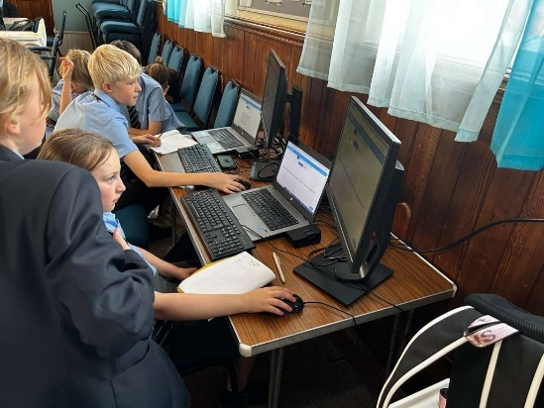
Ruth often provides thoughtful craft activities on special occasions which the are a great way of engaging with the children. We also have lots of conversations around all kinds of subjects, from helping with homework to talking about future plans, football, faith, world news and everything else!

With regards to the future-

We face the possibility that the high school are changing their hours and the proposal is that the children will finish early on a Friday instead of a Tuesday.
This will be a challenge we might not be able to meet. We are asking for prayer in discerning the way forward.
We wish to continue to reach out to the young people but might not be able to offer thrive in the same format.

Emma Smith

Sunday Youth Church
Ramona, Ruth & Tracy continue to lead the sessions for the primary aged children on a Sunday morning. Charlotte was our regular helper until September when she left for university and now Daisy Burke is volunteering with us as part of her Duke of Edinburgh Gold Award. It is great to be able to provide this opportunity for our older teenagers and the kids really enjoy having them in the group.
We have changed from using Superbook to the RaiseUp Faith material which is the same as T412 and provides some continuity when the young people are all in together on the first Sunday of the month. We have been looking at the story of creation, the life of Abraham focussing on the theme of trusting God, and most recently the life of David and the ways in which God helped him -and helps us too.
The children really benefitted from the prayer session led by Vera in the autumn and it has been encouraging to hear the children share their prayers including recognising when those prayers have been answered. The children are the first to suggest prayer as a first line reaction to a problem such as technical issues with the computer.
It has been a blessing to see the children and leaders grow to trust each other, as we together learn Bible stories and what they mean for our lives. Our desire is that the children would grow to know God for themselves & understand what a life of faith looks like as they learn from those who have gone ahead of them. Please do talk to them about what they have been doing and join us in praying about the future of this work.
We continue to face the challenges of a small team, significant variation in numbers of children from week to week, and the large range of abilities in children from Reception to Year 6. It would be good to have new people joining the team and for the young people to feel more connected to the wider church. If you feel God may be calling you to be part of this work, please come and speak to us.

Ruth Rallan

T412

T412 is the group myself and Grace run at WBC aimed at the school years 7 and above. The name is derived from the passage 1 Timothy 4:12 which says ‘Don’t let anyone look down on you because you are young, but set an example for the believers in speech, in conduct, in love, in faith and in purity’.

It is our belief that we should not look down on our young people but instead should listen to them as we can learn as much from them as we can teach them!
It is clear in listening to them that they are growing in faith. An example of this is when Daisy shared how she had been reading her bible studying the whole new testament in a year!
Other examples are the youths willingness to share prayers and questions they have.

Our greatest challenge sadly seems to be that the youth, or indeed we are youth leaders, do not feel that the whole church values them and that they seem to be an after thought. Whilst these reports are to encourage they are also a time when we are to be honest. Indeed our church vision is to be ‘an authentic church, with a place for everyone’.

The youth feel that the songs we sing in worship are often older and not of a style they would choose. They also feel that they have minimal input into the worship element of the churches life.

Some of this could be that for many of them the only contact they have, is with the same Sunday school teachers that they have had ever since they have been here and sadly, despite our best efforts we can become stale as it is always the same voice that they hear.

Going forward it would be really good to see more people involved with our youth, to ask them for their input with regards to worship songs and perhaps if we as a church could ask ourselves are we giving our youth the best or just what will do?

We use Raise up Faith resource for both groups now and T412 have used One Story Jr High curriculum these are some of the subjects we have been looking at -

Genesis - Creation
- Perfection
- People
- Rest
- Broken

Genesis - Trust
- Confused
- Impossible
- Ridiculous
- Promise
- Afraid

Emma Smith

Friday Night Youth
Emma and I have been running Friday night youth group for around 10 years now! We have been supported by Jamie Burke for many of those years and in recent months have also been joined by Jason O Dell.
It is a real blessing to look back and see how some of our young people have grown, not just physically, but also spiritually. It is often the case that you do not notice growth until you look back. Our numbers on these evenings fluctuates, as they have done throughout the years, where there were points in the past year when we were really low on numbers and to be honest we considered the viability of the group. However, it was on reflection when we looked at how God has worked through the young people in the past we felt it wasn’t time to give up yet. We have since seen our numbers on the increase. But for us it is the growth in the young people’s faith which has been so encouraging.

The evenings consist of the young people having 45 minutes of free time where they can meet up, play various different games or just chill. Then we have tuck, where they take it in turns to serve one another. For the final half an hour we spend doing some teaching.
Since the start of the year we have changed things up whereby we now play a worship song via video, then they play a team game based on the theme for the evening, some Bible study and a memory verse for the session and we close in prayer, reflecting on what we have been studying.

We have also enjoyed over the past year some fun evenings such as taking the youth to Kings Head meadow for some cricket, also tubing at Norwich ski slope and the Christmas party which the group ask for every year and so enjoy.

God has been evident in the group as we see them sharing prayers, asking questions, encouraging each other and in the way they engage with the studies.

Going forward we would ask for your prayers in the continued growth both in numbers and the youngsters’ faith, for energy to keep going, and for the wisdom to know when it’s time for us to stop, if that is indeed what we should do, but more importantly that we disciple others to help take this group forward.

Finally thank you for allowing us the space and the support.

Blessings

Paul, on behalf of the Friday night youth team.

Secretary
As I write this report I am very aware of how inadequate I feel in the role of co-opted Church Secretary. With God’s help I am trying to do my best for as long as He wants me to.
Early in 2023 we were thrilled to be able to celebrate Paul’s ordination. This was the climax of years of study for Paul and the end of one stage in the church life and the beginning of another as we seek to follow God, seeing Him at work in Wymondham.
In March we were pleased to be able to offer our premises for an away day for the leadership of Carleton Rode Baptist Church. This is something we would like to be able to offer more one the building is extended and we have a flexible space that can be used.
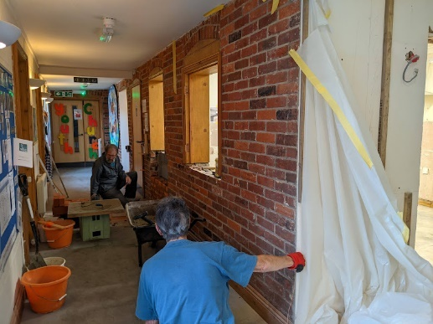
Initially the leak in the kitchen seemed to be another mountain to climb, but God had everything in control and showed us how we should use this disaster to take the first step in our progress with the vision that God has given us, in re-modelling our kitchen for future use as part of the extension. God provided us with the expertise of both Penny and John Seall and Paul and Emma.
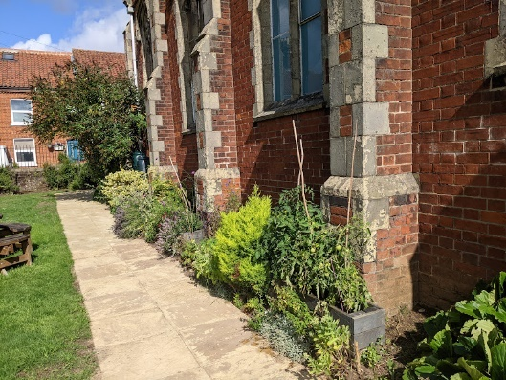
Another step in our vision path was the holding of another Alpha course. As we look to the next course later in 2024, we are praying that God will speak to more people on the fringe of the fellowship to come along and join the course and feel able to ask those important questions.
On a couple of Saturdays during the early summer a group of members of the fellowship came together to install the path in the church garden. We are pleased to now have a little team of people working on our church garden. The plan is that in time our church garden can not only be used by the church fellowship, at Roots but also used by members of the local community – a quiet space for reflection and prayer. The efforts of this team were rewarded by official recognition from Wymondham in Bloom when we achieved ‘Outstanding and Most Creative’ award.
By working with Rosedale Funeral Services, Paul has led a number of funerals in the church, not only for members of the fellowship but also for members of the community. Emma and some volunteers have been able to serve refreshments after the services. This has been another way in which we can show the love of God to our community.
During the year we have been able to support Ketts Books by allowing them use of the premises for their Author events. Wymondham Youth Music Society have also held concerts at the church. We were also thrilled to be able to welcome the Hemsby Singers in December. The concert that they gave was wonderful and we look forward to their return on two occasions in 2024 – make sure you don’t miss these visits – thank you to Norman and Helen for arranging them.
Trussell Trust foodbank continue to operate from the church premises on Friday morning. As part of this service a representative from Shelter is also available for help and advice.
As a Leadership Team we meet monthly. At these meetings we spend time seeking God’s guidance for our church fellowship, sharing the responsibility, as your representatives, for the practical aspects of running the church. We also spend some time praying for guidance in all aspects of church life.
As we look to the future we know that God will continue to work and we encourage you all to pray continually that we will be aware of His presence and guidance. We long to see miracles happen here in Wymondham, more people come to know Him and the start to the building project, literally digging in the car park!! God can do it, he needs us to be His hands and feet here in Wymondham.
Cathy Finch

Church Administrator
During 2023 I have continued to be present in the church office on Tuesday, Wednesday and Friday mornings. I have tried to keep track of church policies and endeavoured to keep them up to date and regularly reviewed by the Leadership Team. I have also endeavoured to ensure that the general notice boards around the church are kept as up to date as possible. Paul and I spend some time together on Tuesday morning checking through work that needs to be done etc. etc. On Wednesday morning we test the fire alarm and emergency lighting.
As part of my role I am responsible for the church duty rotas for the Welcome Team, Refreshments Team, Communion Team and the Duty Deacon. I am grateful to all those who have helped in these duties and would welcome some more volunteers on these teams. Please let me know if you think you might be able to help. I am grateful to Robbie Hilton who has agreed to take responsibility for the Welcome Team. These Sunday duties are vital to the work of the church as a warm welcome will usually mean that visitors will return and want to engage with the work here at WBC. Please let me know if you would like to volunteer on one of these teams.
During the year I have endeavoured to prepare an up-to-date weekly notice sheet, and bi-monthly magazine – The Rooted Life. If you want something added to either of these publications, please let me have them. Both are posted on the website. I also endeavour to keep the website up to date. If you have something you would like included on the website, let me have it and I will do my best to include it.
I try to regularly review the notice boards, the Fellowship directory and keep in touch with those we don’t see very often. I have appreciated your prayers and your support, please continue this during 2024.
Cathy Finch

Treasurer
We have so much to thank God for in his provision for us during 2023. As we entered 2023 and indeed even toward the end of 2023 we anticipated that we would encounter a shortfall at the end of December 2023, in fact we ended the year with money in hand in the General Fund. Thank you for your continued sacrificial giving. Particularly as we faced increased expenditure in connection with the kitchen refurbishment, which came in on budget with all costs met.
During 2023 we have continued to tithe our income and given this to GEM in support of Rachel Spencer, to the BMS and to the Falconer Trust. We have continued to seek to upgrade the manse, replacing windows etc – there are still windows etc to be attended to in future months. Keith has regularly dealt with jobs around the church and we have managed to install a path in the garden to help us meet the need for a fire exit for those with reduced mobility.
We are grateful to Mary (Church) and to Alison (Roots CC) who deal with the regular input of data on to our book-keeping programme, paying bills and raising invoices as necessary. Reports are regularly presented to the Leadership Team for their questioning and consideration.
Mary Wright and Cathy Finch – Finance Team

BALANCE SHEET AS AT 31.12.2023
 | As At 31.12.2023 | As at 31.12.2022
Fixed Assets | 0 | 0
Current Assets:-  Cash in Hand – Church  Cash in Hand – Roots C.C.  Church Bank A/c & Savings A/c  Roots C.C. Bank A/c & Savings A/c | 95.00  150.00  35,973.80  14,764.90 | 95.00  150.00  32,315.31  19,261.97
TOTAL | 50,983.70 | 51,822.28
Represented by:-
Unrestricted – General Fund | 4,610.65 | 2,123.05
Designated – Fellowship Fund  Kitchen Fund  Reserve Fund  Roots C.C. | 124.59  356.92  12,500.00  14,914.90 | 131.17  0  11,900.00  19,411.97
Restricted – Eco Church  Alpha  Building Fund  Home from Home | 516.85  245.00  17,293.57  421.22 | 384.48  282.50  15,435.06  2,154.05
TOTAL | 50,983.70 | 51,822.28

STATEMENT OF FINANCIAL ACTIVITIES
1.1.2023 – 31.12.2023
 | Unrestricted  And Designated funds | Restricted Funds | Total Funds  2023 | 2022 Total Funds
INCOME:-
Donations | 56,934.64 | 1,150.74 | 58,085.38 | 68,008.96
Income from Charitable Activities | 25,006.88 | 702.68 | 25,709.56 | 29,630.09
Other Income | 47,524.80 | 1,235.77 | 48,760.57 | 45,990.38
TOTAL INCOME | 129,466.32 | 3,089.19 | 132,555.51 | 143,629.43
EXPENDITURE:-
Expenditure on Charitable Activities | 29,324.90 | 435.32 | 29,760.22 | 25,155.65
Other Expenditure | 102,700.55 | 933.32 | 103,633.87 | 90,914.25
TOTAL EXPENDITURE | 132,025.45 | 1368.64 | 133,394.09 | 116,069.90
NET INCOME/EXPENDITURE before transfers | -2559.13 | 1,720.55 | -838.58 | 27,559.53
TRANSFERS:-
Gross transfers between funds – in | 11,483.52 | 0 | 11,483.52 | 1,371.48
Gross transfers between funds – out | -9,983.52 | -1,500.00 | -11,483.52 | -1371.48
NET MOVEMENT IN FUNDS | -1,059.13 | 220.55 | -838.58 | 27,559.53
TOTAL FUNDS BROUGHT FORWARD | 33,566.19 | 18,256.09 | 51,822.28 | 24,262.75
TOTAL FUNDS CARRIED FORWARD | 32,507.06 | 18,476.64 | 50,983.70 | 51,822.28

Music in Worship
The music team currently consists of Neil, Vic, Mary, Owen, Katie, and Lara. We are also grateful for the work of the Tech Team on the sound desk. Our thanks also to Chris and Susie who departed the worship group in 2023.
During 2023 we operated a rota system, with the intention of giving each member of the group the opportunity to be part of the worship from within the congregation. This gives us an important insight into the experience of sung worship for others.
Our aim is always to try to provide an environment within which everyone in able to express their own worship freely, while being part of the corporate expression of worship. This is always a difficult balance to strike, as everyone has their own preferences in terms of style of worship and choice of songs and hymns, but we hope to create an environment within which everyone is able to feel part of the worship experience. In 2024, monthly evening praise and worship meetings are planned, in which everyone is encouraged to explore new and varied ways of expressing their worship, not only through song, but through art, dance, poetry, or any other means of expression.
Neil Starling

Buildings, Garden and Maintenance
As you read this report, please bear in mind it goes hand in hand with other reports, i.e. kitchen and preparatory work for the new build.

My thanks to Keith Hilton who is the man going around with drills and screwdrivers, repairing and replacing as necessary. Many of these jobs are comparatively small works, but nevertheless keep our premises up to scratch.

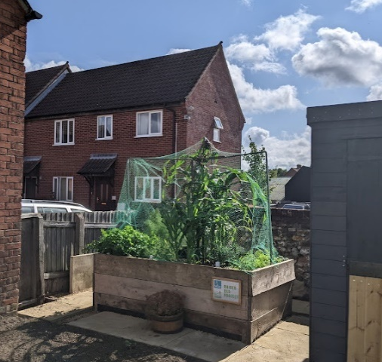
Some of the jobs included removing the old church signboard at the end of the school rooms and making good to receive the new logo and lettering. One of the larger jobs, involved the preparing and laying of the new pathway in the garden alongside the church with retaining boards. The shed in the garden has been repaired and re-painted and a new hose system installed. A raised bed was constructed by Keith and Daniel, and we have already had our first crops. My thanks to those who have worked so hard in making our church garden attractive and a usable space, where we enjoyed the church barbecue. The long list of jobs carried out shows what goes om ‘behind the scenes’ even like light bulb changing, toilet seat replacement and some decorating. Keith would be able to give you a comprehensive list.

The guardianship of the buildings we have been entrusted with includes our church’s manse and as I have reported before, my thanks, on behalf of the church go to Paul and Emma who keep our manse in such good decorative order, and we are so grateful for the love and care they show. Not only is the house kept well, but the garden also. As you know from Church Meetings, we have had some more replacement windows fitted which is quite a large expense. In the coming months, as passed by the Church Meeting, some more windows and the front door will be replaced.

It is good to know that in keeping our premises up to a standard we are able to have rooms used for prayer, foodbank and Rosedale Bereavement groups. Paul’s office has now been relocated to the other end of the school rooms.

In keeping our premises safe we have regular tests on our fire alarm system and electrical and extinguisher checks.

I feel that we have been honouring to the buildings that we already have and are making great use of them. Now, we look forward to being entrusted with bigger premises as we reach out to those in our community and further afield.
Vic Wright
Outreach and Mission
Many of our Mission and Outreach activities and connections are covered in other reports, but here are others that are not:
Rachel Spencer
Rachel is working in Paris with GEM (Greater Europe Mission) seeking to bring the gospel to a nation which is deeply secular, though with a significant Muslim population in the region where she is living. She is doing this in a number of ways, including English language classes, parenting classes, and partnering with other Christians and organisations. In November she attended a training weekend run by the Alliance Biblique de France (French Bible Society) to be able to facilitate groups supporting people who have experienced trauma.
She writes: “I’ve had some very good conversations with the local Catholic priest this term, who is very open to working together and appreciates the different perspective that I can bring. He has invited me to get involved in the life of the Parish in various ways, and I have agreed to help with pastoral visiting of older or isolated people, and with baptismal classes for adults.”
As well as her outreach work, Rachel is studying for a PhD. In September 2023 she visited the UK for the annual conference of the Ecclesiology and Ethnography Network in Durham. This was three days of presentations of research in Practical Theology, Pastoral Theology, Missiology… anything relating to how people live and experience their faith, their church life, or their ministry.
At WBC we support Rachel’s work through our church tithes as well as our prayers.
Alan and Megan Barker
Alan and Megan Barker are currently based in Kathmandu, Nepal working under the umbrella of BMS. Megan works as an occupational therapist, and Alan works in project management.
In January 2024 we were privileged to have Alan and Megan visit us and share in our morning service. They have been able to spend time visiting several churches during their time in the UK, as well as seeing family and friends. It was good for us to have the opportunity to learn more about their work, and about their everyday life in Nepal.
Alan and Megan report that in November an earthquake hit Nepal. Many homes were destroyed and HDCS, the BMS partner organisation that they are seconded to, has begun to help one village to rebuild. This includes building earthquake resilient homes and training local builders in their design and construction. Alongside this they have been helping teachers and students to get back to school and also supporting disabled people with donations of warm clothes and blankets.
Megan is thankful for the Association of Nepal's Occupational Therapists (ANOT) being both recognised by the government of Nepal in spring 2022 and then accepted into the World Federation of OTs (WFOT) in December 2023.
Neil Starling

The Falconer Trust
The Falconer Home in Kabulamema, Zambia currently provides a home for around sixty children of all ages from 2 years to mid-teens.
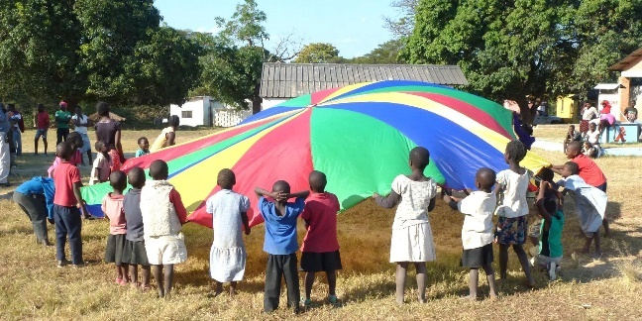
In June 2023 Neil visited the Home, along with one of the trustees, Dennis Webb. This was the first visit since 2019, with the Covid pandemic having prevented visits in the intervening years. They were able to observe a great deal of building work which is taking place in order to provide improved accommodation for the children. An old derelict church is being converted into a girls’ dormitory, which will include toilets, showers, and a kitchen and social area. Two further buildings are also being built – a toilet and shower block next to the boys’ dormitory, and a kitchen, both required by Social Welfare in order to meet their requirements. This work is obviously placing great demands on the Trust’s financial resources.
Neil will be visiting the Home again in May or June – dates yet to be decided.
Following the resignation of two trustees in January 2023, new trustees are still being sought, to work alongside the three remaining trustees. Please pray for the team as we seek the way forward in all aspects of the work.
The Trust is very grateful for the financial support given by WBC through its tithes.
Neil Starling

Homegroups at WBC
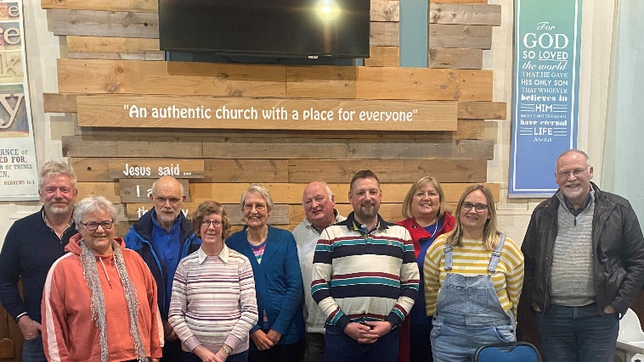
WBC made good progress with developing our homegroup structure in 2023 and by the end of the year, had grown from 3 groups (29 members) to 6 groups (50 members). We discussed and agreed with church members the purpose of WBC homegroups and the role of our homegroup leaders. Termly meetings for homegroup leaders were set up, for mutual encouragement, sharing and learning from each other’s experience. Our pastor Paul Smith updates them on how homegroups underpin our church’s vision – this way, we are all connected into the heart of the church’s vision, as Jesus told us all to remain connected to Him, the True Vine.

WBC’s vision is that everyone in the fellowship has opportunity to join a homegroup and we are strongly encouraging this. We have created a leaflet for people interested in joining a group, explaining how WBC homegroups are a vital part of our church life, providing an opportunity for ‘friendship, fellowship, family, food and fun’. Our website information will soon be updated as well. Depending on the need, we may seek to set up another homegroup(s) in 2024.

Our homegroups are a network of loving, genuine relationships which support pastoral care and discipleship at WBC. We are hugely grateful to all our homegroup leaders for their commitment and their key role in making this happen.

Vera Cooke and Gill Price

ECO Church
We have now had 2 years of affiliation with the A Rocha charity and with Eco Church. This affiliation goes hand in hand with our church’s vision and mission.
The vision of Eco Church is as follows: ‘for churches of all denominations to care for creation as an integral part of loving their neighbours and following God faithfully’ (taken from Eco Church website).
At Wymondham Baptist Church, our church vision is centred on elevating and worshipping God in all that we do, engaging with and serving our wider community and looking after our environment and buildings.
Eco church encourages us to express our care for God’s creation in the following areas:
- in our worship and teaching,
- in looking after our buildings and land,
- in engaging with our local community and in global campaigns
- in the personal lifestyles of our congregation.
So, how did we honour God and the Eco Church/WBC vision in 2023 and what did we do to build on the Bronze Award we received in November of that year?
Honouring God in our Worship and Teaching
Led by Ruth Rallan, our young people spent one Sunday session looking at the importance and awesomeness of trees and the many roles they play in the environment. Then, on these pieces of cut birch wood (see image above), we made a pledge on how we would help to look after the trees around us.
In October, as part of the preaching series ‘God’s journey with Jacob’, we looked at the ‘Tipping Point’ and were hopefully encouraged again to hear that we can all make a difference to our world by the many small and simple choices and actions we make daily.
Our church flower displays are also an act of worship. Jan prepares and arranges our flowers each week to enhance our building and our worship. Since joining the Eco Team, Jan has been giving thought to how she can source and arrange our flowers more sustainably, from no longer using oasis flower foam to using flowers and greenery from our own gardens. Thank you Jan.
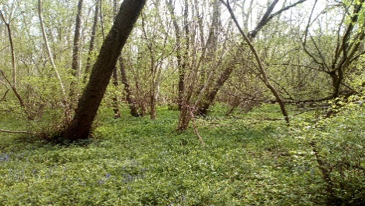
Spring Worship Walk
This took place on Sunday 30th April from 3 -5pm in Ashwellthorpe Woods. It was a beautiful afternoon and 20 of us spent just over an hour walking round these beautiful woods, looking at and listening to some of the local wonders of creation: bluebells, wild garlic, early purple orchids, butterflies and a host of birdsong. We hope that it was a reflective but exciting time of fellowship and worship in the open air.
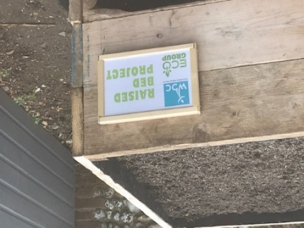
Looking after our buildings and land
In March, Keith and Daniel made a wonderful raised bed which Keith then erected in the church garden. He planted seeds which we were able to share out among our fellowship. Ruth and Daniel Rallan have planted some over wintering seeds and we will encourage our church community to share and use the produce as it ripens.
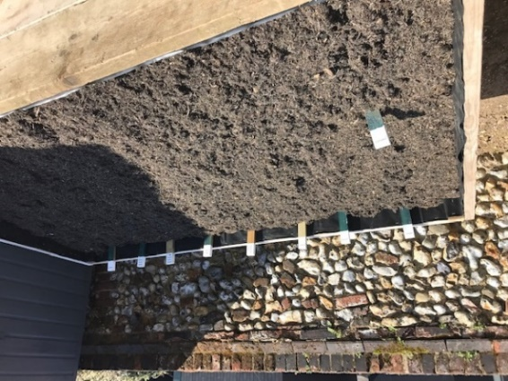
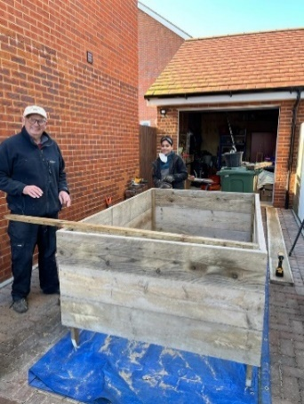
We have a wonderful team of people who look after our garden, watering, weeding, mowing and planting. We are focussing on replanting flowerbeds with more pollinator friendly plants to increase the biodiversity in the garden.
As a church, we took part in Wymondham in Bloom which this year had a theme of edible displays. Again, our garden team produced some really creative, beautiful and delicious displays of herbs, tomatoes and strawberries which we were able to enjoy as they ripened.
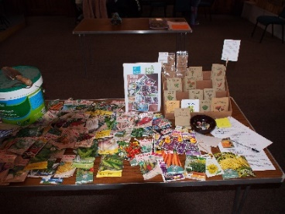
Engaging with our local community and with Global campaigns
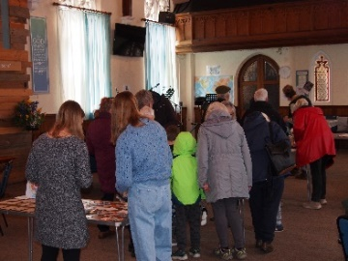
Seed Swap event: This took place on the 4th March 2023 and was a real success, bringing together many community groups in the town including The WI, the allotment association, Greening Wymondham and Browick Road Junior School Gardening Club. Encouragingly, we also had people come who had seen the event on Facebook and advertised through the Rosedale’s Bereavement Group. The remaining seeds were divided up and donated to several other local groups who are looking to improve their outdoor spaces. The event could not have happened without the strong support of members of WBC.
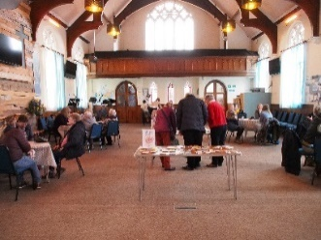
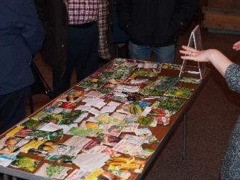
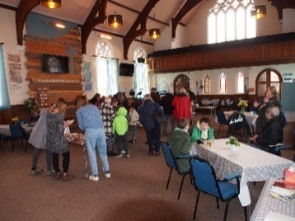

Summer Supper with Speaker: On the 2nd June, we invited members of our fellowship and the wider community to come and share in a ploughman’s supper and then hear Hannah Gray who is a volunteer speaker with A Rocha. We had guests from Greening Wymondham, The Abbey Eco Team and Wymondham Nature Group. It was a positive evening with an interesting talk about the climate crisis and our role and responsibilities.
The Great Big Green Week (GBGW): As a church, we took part in the GBGW in our 2 Roots café sessions. Emma and the Team kindly provided a greater variety of plant-based food, there were colouring sheets based on trees for the children and we had a Powerpoint running showing the WBC Eco church activities.
September 2023: TWAM Tool collection day: While not exclusively an Eco
Church event, it is included here because the TWAM charity cleans, mends
and repurposes tools before sending them to Africa to be used in helping
people set up local businesses. The charity saves about 405 tonnes of tools
from landfill therefore saving about 1,134 tonnes of CO2 every year. By
supporting TWAM and its ethos of sustainability, we are making another
positive choice in looking after our environment.

Caring for God’s world in the personal lifestyles of our fellowship
Recycling:In February 2022 we started a recycling scheme at WBC for items that cannot be recycled by the roadside collections. Our used stationery items are taken to Rymans in Norwich while other items are taken to Val Keel in Wreningham to be recycled via Terracycle. Unfortunately, we had to stop the collection of blister packs at the end of 2022 but expanded the recycling in 2023 to include crisp packets. We have a recycling notice board in the corridor with all the information about our scheme.

New coffee: Roots has changed to a Lavazza coffee. Lavazza is Rain Forest Certified and supports growers in 17 countries through a variety of sustainability projects. They are working towards lower-carbon emissions, more reforestation and sustainable cultivation and to improving the recyclability of their packaging.

Rooted Life magazine: Regular Eco Church updates, eco tips, and suggestions are included in the Rooted Life magazine, both from members of our fellowship and from Nicola Maunders from Greening Wymondham.

Eco Church Calendar 2024: This was a truly team effort as we had contributions from many people from our fellowship …..photos, artwork, recipes and eco tips. It was very well received and about 50 copies sold. All proceeds will go towards Eco church projects in 2024.

Christmas card display board: We were delighted that so many of us chose to ‘send’ just one Christmas card to the whole fellowship. The board looked beautiful and the messages inside them were heartwarming. Instead of throwing them away, we will reuse the fronts of the cards to make some Christmas bunting for Christmas 2024.

Plans for 2024

We have already enjoyed a New Year’s Day walk and lunch.
Over the Easter weekend, we are organising an Easter Garden display to enhance our worship and meditations.
We are also planning several community clothes swaps: 2 school uniform swaps in the spring and summer and a Community Christmas Jumper Swap on the 16th November. We will keep you up to date with the details of these events nearer the time.

And finally….

Finances: We are a self-funding group and with the funds raised this year, we have given a £100 donation to A Rocha charity. A further £268 was spent on materials for the raised veggie bed and some sand and shingle for the area around it. We also purchased a new hose with a long extension to make watering the garden easier for our gardeners. We have a balance of £516.85 at the start of 2024. This will be used throughout the coming year on Eco Church projects in the garden and around our building.

In November of 2022, we were delighted to receive the Bronze Eco Church Award and are hoping that this will inspire us to look for more and more ways to put our love for God’s creation at the heart of everything we do at Wymondham Baptist Church. We are aiming for our Silver Award in 2024.

As a fellowship, we are hugely supportive of each other and once again, we would like to thank everyone who has supported the Eco Church activities and events over this year, both with their time, skills, and finances. It is very much appreciated.

The team meets about every 6 weeks, and we would be delighted to see new faces or to hear from anyone who has ideas for future projects.

Nicki Waterworth on behalf of the Eco Church Team

Café Church
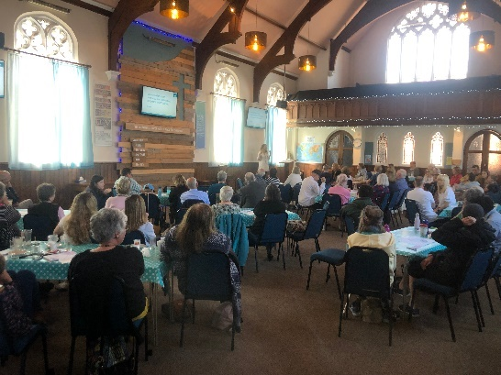
Café Church was originally introduced in 2019 and is now settled into a recognisable format which is well established in the WBC calendar. The intention of Café Church is to offer a less formal introduction to our Sunday morning services. We have a lot of people who visit of church throughout the week or who meet our regular members, and we know that some of these find it hard to consider coming to church on Sunday. Some have been put off due to past experiences or some have negative perceptions about what it will be like. Café Church aims to offer a stepping stone for people who are not quite ready for the full service but are comfortable with a service which looks a bit like Roots Café.
The services are always well attended, and we are pleased to report that we consistently have at least one person who attends specifically because its Café Church. A particular highlight from this year was seen during Vic's service when a non church attending young man stood up and got actively involved. Clear evidence that we were able to make him feel welcome and comfortable at WBC.

The Café Church team are Owen, Vic, Matthew and me and we each lead a different Café Church service an annual basis. Using a film to help deliver a godly message has worked so well that we have decided to continue this into 2024/25, with 4 new films now being advertised: The Lion King, the Plank (a short film), Harry Potter and E.T.

We routinely undertake questionnaires after a service and the feedback has been positive, with some ideas also being suggested which the team will discuss when we next meet. The Café Church sessions are a team effort, requiring a lot of people working both upfront and behind the scenes. We thank everyone who has helped to make Café Church a success and we look forward to seeing more fruit from our labour in the coming year.

Grace Burke

Care in the Community/Home Communion
This ministry has continued throughout 2023, responding to requests for home visits, including those when we specifically 'break bread' together. All requests this year have come from members of our fellowship who are housebound or have mobility issues, or find they are able to participate more fully in communion in a smaller, home setting. A couple of potential befriending visits were discussed with Carers who made contact with WBC, and we are waiting to hear if these will be followed up at any stage.
This year we have worked on our home communion leaflet/’order of service’ and have updated, simplified wording and increased readability (size of font etc). In addition we drew on Baptist Union templates short home communion services which were helpful. We’ve trialled this new leaflet a couple of times and it’s working well, and is available for homegroups and any other context where people are breaking bread together informally.
The Church Office is informed of each visit and the team goes in pairs. Home visits are personal and those going into people's homes are subject to the church’s safeguarding protocol and the need for confidentiality. Those who have visited this year are Shirley Marwood, Nicki Waterworth, Penny Seall, Frances Sullivan, Jane Poyntz and Vera Cooke.
It’s a privilege to be used in this way in this quiet ministry and the appreciation shown has been both encouraging and humbling. If you know of a need then do chat with a member of the Team or ring the Church Office for details. We look forward to continuing this valuable ministry in 2024.
Shirley Marwood and Vera Cooke

Home from Home
Home from Home our Warm Space ran during 2023 until April 2023. Thank you to all those who took up the challenge after Ray died and I didn’t feel able to take a lead.
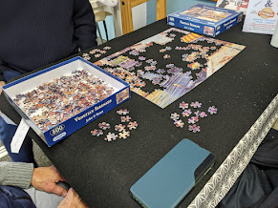
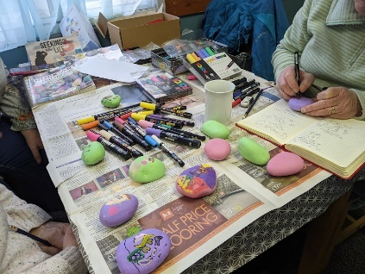
During the warmer months (apart from when the work was in progress in the kitchen) the group continued to meet on the second and fourth Thursday of the month. We have continued to meet in this way since September. The numbers accessing this service have been quite low, however, those attending have found it a source of warmth and friendship, a listening ear, conversation and support as much for those volunteering at the group as those we welcome from the community.
Once again we have been successful in our grant applications to the Norfolk Help in the Community Grant and Norfolk Community Foundation this year we applied on behalf of Roots and Home from Home as both services offer a valuable warm space and friendship to all who come along.
During 2024 we will be considering whether this is a service that we continue to offer or whether we focus on other areas to support our community.
Cathy Finch

Building Project Team
Proposed Extension
Give thanks for approval of the planning application for the proposed extension in late 2022!

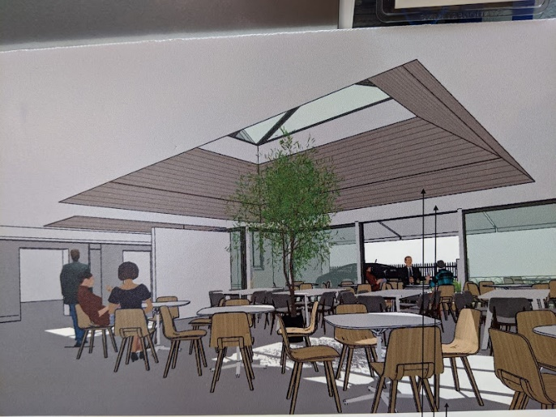
Early in 2023, building upon the great work done by Ray Finch and others we reviewed the use of the premises and location of the existing underground services. We have prepared a report to go to the architect to inform the next phase of the work, which includes the detail drawings and specification of the work required to obtain prices from builders.

Quotes totalling £30,000 for this detailed work have been obtained from our architect, structural engineer and independent energy consultant and approved by a Church Members Meeting in November 2023, subject to having the necessary finance. We are hopeful that this work will start in April 2024. We already have £17,000 in the Building Fund, but we need to have the bulk of the funds or promises of funds before we can start. This will still be true even if we are successful in obtaining the community grant being applied for, as we have to pay for the work first and reclaim the grant afterwards.

When this detailed work is done, it will enable us to obtain prices from builders to do the work. This could potentially enable us to start construction later in 2024, but more likely not before Spring 2025, dependent of course of having the necessary finance.

Give thanks too for the sterling work of Paul and Emma Smith and John and Penny Seall who have used their skills to provide us with an upgraded kitchen in advance of the extension, having been pushed into doing something a result of a burst water pipe. Give thanks too for the funds to do this work. God has been good to us.

We have a way forward but it is still hard to see where all for the money need will come from. The total required to complete the extension is approximately £500,000. Please pray that God’s will may be done.

A more detailed report is available for those who like to read it – please speak with Cathy in the Office who will give you a link to the full report.

David Frith

WBC Building Project External Fund-Raising Steering Group
(Creating a place for Everyone)

Since August 2023, the group has met five times with the objective of developing a business case and associated documents to enable the group to apply for grants to raise funds for the building extension.
By February 2024, the steering group has developed:
- A business case to be used to apply to grant awarding bodies. The business case contains, the background to the project, a revised audit to explain why this project is so important, together with a marketing strategy and financial information.
- A project programme (timeline) for the building of the extension.
- Developed a database of potential funders, approximately 25+ to date.
- The impact of the extension over the coming years (Outcomes). This will enable the group to track the changes over time.
- Submitted an application in January 2024 to South Norfolk Council to obtain a grant from the Pride in Place fund to undertake a feasibility exercise for the extension project.
Members of the steering group have presented to the Leadership team in January 2024 and also to the church meeting. Approval was sought and given to proceed approaching grant award bodies in the spring of 2024.
Next steps
- Await the outcome of the Pride in Place application.
- Further refine the business case.
- Plan a schedule of grant applications to commence as soon as possible.
- Commence the outcomes baseline.
- Continue to refine database grant awarding bodies to identify any gaps/other potential funders.
I give thanks for the work of others; Grace, Cathy, Keith, David and Ray, together with Paul and the Leadership Team for the help, support and prayers for the group. Please continue to remember us in your prayers.
Kate Kinsey

Windmill House

I'm delighted to report that in 2023 we were able to visit Windmill House 6 times to lead a simple worship service for the residents, together with some of the staff caring for them and sometimes a few visitors. When we can all be there we are a team of 5 - Vic, Mary, Christine Frith, Doug and me. Many of the residents are living with quite advanced dementia and may have difficulty holding a conversation but still know and love old familiar hymns.
Windmill House had been going through a difficult time in 2023 and went through many staff changes. We were still made very welcome during that time. Fran Annis who had been Wellbeing Lead for many years, loved working at Windmill House and was always very enthusiastic about our visits, left for a few months to work at a different care home but I'm glad to say she returned in the summer.
Highlights of the year were a Harvest Thanksgiving Service in September illustrated with colourful pictures by Vic and enjoyed by all who were there, and our first live Carol Service for many years with (LED) Advent Candles, a short talk about the birth of Jesus with a baby doll representing Jesus (cuddled by several of the ladies after the service!)
Our aim always is to bring 'church' to those who can no longer go to a church building, to assure the residents that God loves them and cares for them. We never rush away after the service but spend time sitting talking with the residents.
Please continue to pray for this ministry and for all who live and work at Windmill House.

Jan Hodges

GALLERY FROM 2023

